Joel Atkinson
May 2, 2026
CSD440 Server-Side Scripting
Assignment 8.2
JoelCreateTable code:
<!-- Joel Atkinson, April 28, 2026. CSD440 Server-Side Scripting Assignment 8.2
The purpose of this program is to connect to the baseball_01 MySQL database using
MySQLi and create a new table named joel_mlb_teams. The table is used to store
information about Major League Baseball teams and contains eight fields covering
two different data types (INT and VARCHAR). The result of the CREATE TABLE
statement is reported back to the user in a formatted page along with the
structure of the new table.
-->
<!DOCTYPE html>
<html lang="en">
<head>
<meta charset="UTF-8">
<meta name="viewport" content="width=device-width, initial-scale=1.0">
<title>Joel's Create Table</title>
<style>
body {
font-family: Arial, sans-serif;
margin: 0;
}
.banner {
background-color: #663399;
padding: 20px 40px;
}
h1 {
color: #DAA520;
margin: 0;
text-align: center;
}
h2 {
color: #663399;
text-align: center;
margin-top: 30px;
}
.divider {
border: none;
border-top: 3px solid #DAA520;
margin: 0;
}
.content {
margin: 30px auto;
max-width: 700px;
padding: 0 40px;
}
.success-box {
background-color: #e0ffe0;
border: 2px solid #008800;
color: #008800;
padding: 15px 20px;
border-radius: 4px;
margin: 20px 0;
text-align: center;
font-weight: bold;
}
.error-box {
background-color: #ffe0e0;
border: 2px solid #cc0000;
color: #cc0000;
padding: 15px 20px;
border-radius: 4px;
margin: 20px 0;
}
table {
border-collapse: collapse;
width: 100%;
margin: 20px 0;
}
th, td {
border: 1px solid #666;
padding: 10px 20px;
text-align: left;
}
th {
background-color: #663399;
color: #DAA520;
}
tr:nth-child(even) {
background-color: #f2f2f2;
}
.info {
text-align: center;
color: black;
margin: 20px 40px 40px;
line-height: 1.8;
}
</style>
</head>
<body>
<div class="banner">
<h1>Create Table - Joel's MLB Teams</h1>
</div>
<hr class="divider">
<div class="content">
<h2>CREATE TABLE Result</h2>
<?php
// Database connection variables for the baseball_01 MySQL database
$servername = "localhost";
$username = "student1";
$password = "pass";
$database = "baseball_01";
// Open a new connection to the MySQL server using MySQLi
$conn = new mysqli($servername, $username, $password, $database);
// Check that the connection was opened successfully
if ($conn->connect_error) {
echo '<div class="error-box"><strong>Connection failed:</strong> '
. htmlspecialchars($conn->connect_error) . '</div>';
echo '</div></body></html>';
exit;
}
// SQL statement that creates the joel_mlb_teams table.
// The table contains eight fields and uses two different data types:
// INT and VARCHAR.
$sql = "CREATE TABLE joel_mlb_teams (
team_id INT AUTO_INCREMENT PRIMARY KEY,
team_name VARCHAR(75) NOT NULL,
city VARCHAR(50) NOT NULL,
league VARCHAR(10) NOT NULL,
division VARCHAR(10) NOT NULL,
founded_year INT NOT NULL,
world_series_wins INT NOT NULL,
mascot VARCHAR(50) NOT NULL
)";
// Run the CREATE TABLE statement and report the result
if ($conn->query($sql) === TRUE) {
echo '<div class="success-box">Table "joel_mlb_teams" created successfully.</div>';
// Display the structure of the new table so the user can verify the fields
echo '<h2>Table Structure</h2>';
echo '<table>';
echo '<tr><th>Field</th><th>Type</th><th>Null</th><th>Key</th></tr>';
$describe = $conn->query("DESCRIBE joel_mlb_teams");
while ($row = $describe->fetch_assoc()) {
echo '<tr>';
echo '<td>' . htmlspecialchars($row["Field"]) . '</td>';
echo '<td>' . htmlspecialchars($row["Type"]) . '</td>';
echo '<td>' . htmlspecialchars($row["Null"]) . '</td>';
echo '<td>' . htmlspecialchars($row["Key"]) . '</td>';
echo '</tr>';
}
echo '</table>';
$describe->close();
} else {
echo '<div class="error-box"><strong>Error creating table:</strong> '
. htmlspecialchars($conn->error) . '</div>';
}
// Close the database connection
$conn->close();
?>
</div>
<p class="info">
<strong>Author:</strong> Joel Atkinson<br>
<strong>Course:</strong> CSD 440 - Server-Side Scripting<br>
<strong>Assignment:</strong> 8.2 - Create Table<br>
<strong>Description:</strong> This program connects to the baseball_01 database using MySQLi
and runs a CREATE TABLE statement that builds the joel_mlb_teams table. The table stores
information about each Major League Baseball team and contains eight fields across two
data types (INT and VARCHAR). The result of the operation, along with the structure of the
new table, is displayed in a formatted HTML page.
</p>
</body>
</html>

Screenshot of output when navigating to localhost/JoelCreateTable.php:
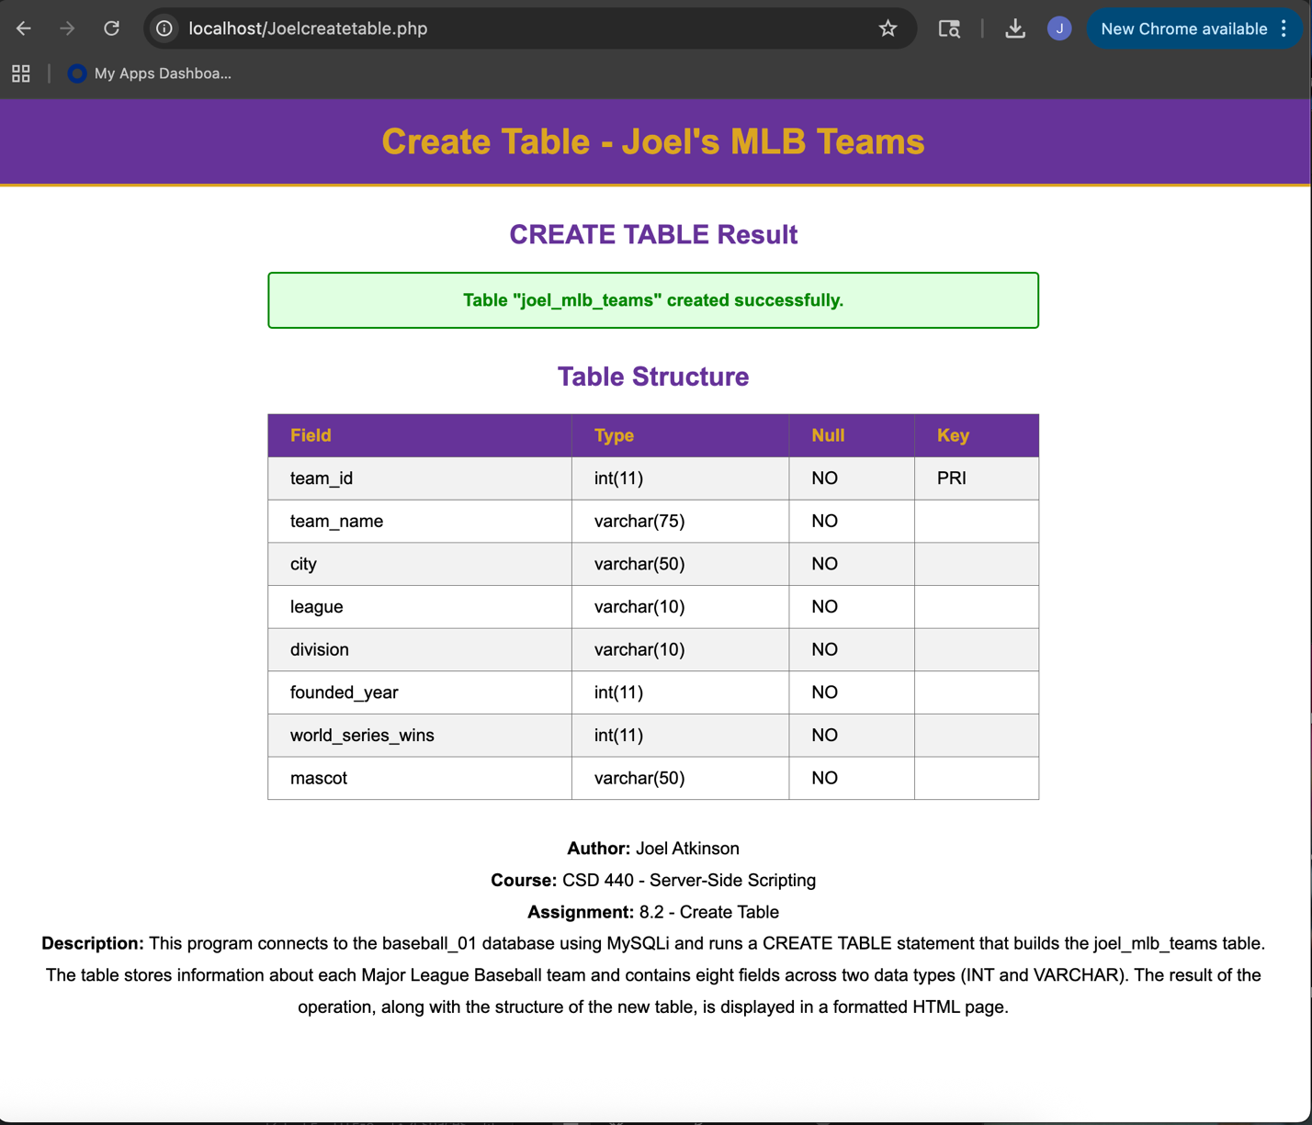
Screenshot of my php XAMPP dashboard showing the table has been created:
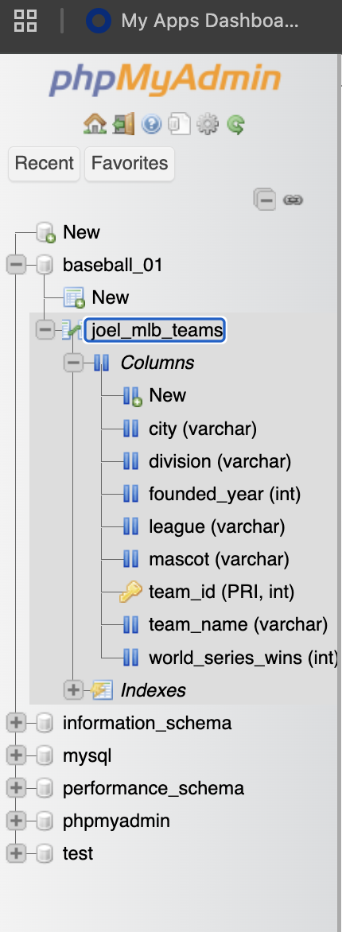

JoelPopulateTable.php code:
<!-- Joel Atkinson, April 28, 2026. CSD440 Server-Side Scripting Assignment 8.2
The purpose of this program is to connect to the baseball_01 MySQL database using
MySQLi and insert all 30 Major League Baseball teams into the joel_mlb_teams
table. Each insert is performed using a prepared statement to safely bind the
field values. The result of each insert and the total number of rows inserted
are displayed back to the user in a formatted page.
-->
<!DOCTYPE html>
<html lang="en">
<head>
<meta charset="UTF-8">
<meta name="viewport" content="width=device-width, initial-scale=1.0">
<title>Joel's Populate Table</title>
<style>
body {
font-family: Arial, sans-serif;
margin: 0;
}
.banner {
background-color: #663399;
padding: 20px 40px;
}
h1 {
color: #DAA520;
margin: 0;
text-align: center;
}
h2 {
color: #663399;
text-align: center;
margin-top: 30px;
}
.divider {
border: none;
border-top: 3px solid #DAA520;
margin: 0;
}
.content {
margin: 30px auto;
max-width: 800px;
padding: 0 40px;
}
.success-box {
background-color: #e0ffe0;
border: 2px solid #008800;
color: #008800;
padding: 15px 20px;
border-radius: 4px;
margin: 20px 0;
text-align: center;
font-weight: bold;
}
.error-box {
background-color: #ffe0e0;
border: 2px solid #cc0000;
color: #cc0000;
padding: 15px 20px;
border-radius: 4px;
margin: 20px 0;
}
table {
border-collapse: collapse;
width: 100%;
margin: 20px 0;
}
th, td {
border: 1px solid #666;
padding: 8px 15px;
text-align: left;
}
th {
background-color: #663399;
color: #DAA520;
}
tr:nth-child(even) {
background-color: #f2f2f2;
}
.info {
text-align: center;
color: black;
margin: 20px 40px 40px;
line-height: 1.8;
}
</style>
</head>
<body>
<div class="banner">
<h1>Populate Table - Joel's MLB Teams</h1>
</div>
<hr class="divider">
<div class="content">
<h2>INSERT Results</h2>
<?php
// Database connection variables for the baseball_01 MySQL database
$servername = "localhost";
$username = "student1";
$password = "pass";
$database = "baseball_01";
// Open a new connection to the MySQL server using MySQLi
$conn = new mysqli($servername, $username, $password, $database);
// Check that the connection was opened successfully
if ($conn->connect_error) {
echo '<div class="error-box"><strong>Connection failed:</strong> '
. htmlspecialchars($conn->connect_error) . '</div>';
echo '</div></body></html>';
exit;
}
// All 30 MLB teams. Each row contains values for the seven non-key fields:
// team_name, city, league, division, founded_year, world_series_wins, mascot.
//
// City rule: the city listed is the city in the team name (for example
// "New York" for the Yankees). For teams named after a state, such as the
// Arizona Diamondbacks, the city listed is the city where the team's stadium
// is located (Phoenix in that example).
$teams = array(
// American League - East
array("Baltimore Orioles", "Baltimore", "AL", "East", 1901, 3, "The Oriole Bird"),
array("Boston Red Sox", "Boston", "AL", "East", 1901, 9, "Wally the Green Monster"),
array("New York Yankees", "New York", "AL", "East", 1901, 27, "None"),
array("Tampa Bay Rays", "Tampa", "AL", "East", 1998, 0, "Raymond"),
array("Toronto Blue Jays", "Toronto", "AL", "East", 1977, 2, "Ace"),
// American League - Central
array("Chicago White Sox", "Chicago", "AL", "Central", 1901, 3, "Southpaw"),
array("Cleveland Guardians", "Cleveland", "AL", "Central", 1901, 2, "Slider"),
array("Detroit Tigers", "Detroit", "AL", "Central", 1901, 4, "Paws"),
array("Kansas City Royals", "Kansas City", "AL", "Central", 1969, 2, "Sluggerrr"),
array("Minnesota Twins", "Minneapolis", "AL", "Central", 1901, 3, "T.C. Bear"),
// American League - West
array("Houston Astros", "Houston", "AL", "West", 1962, 2, "Orbit"),
array("Los Angeles Angels", "Los Angeles", "AL", "West", 1961, 1, "Rally Monkey"),
array("Oakland Athletics", "Oakland", "AL", "West", 1901, 9, "Stomper"),
array("Seattle Mariners", "Seattle", "AL", "West", 1977, 0, "Mariner Moose"),
array("Texas Rangers", "Arlington", "AL", "West", 1961, 1, "Rangers Captain"),
// National League - East
array("Atlanta Braves", "Atlanta", "NL", "East", 1871, 4, "Blooper"),
array("Miami Marlins", "Miami", "NL", "East", 1993, 2, "Billy the Marlin"),
array("New York Mets", "New York", "NL", "East", 1962, 2, "Mr. Met"),
array("Philadelphia Phillies","Philadelphia", "NL", "East", 1883, 2, "Phillie Phanatic"),
array("Washington Nationals", "Washington", "NL", "East", 1969, 1, "Screech"),
// National League - Central
array("Chicago Cubs", "Chicago", "NL", "Central", 1876, 3, "Clark"),
array("Cincinnati Reds", "Cincinnati", "NL", "Central", 1882, 5, "Mr. Red"),
array("Milwaukee Brewers", "Milwaukee", "NL", "Central", 1969, 0, "Bernie Brewer"),
array("Pittsburgh Pirates", "Pittsburgh", "NL", "Central", 1882, 5, "Pirate Parrot"),
array("St. Louis Cardinals", "St. Louis", "NL", "Central", 1882, 11, "Fredbird"),
// National League - West
array("Arizona Diamondbacks", "Phoenix", "NL", "West", 1998, 1, "D. Baxter the Bobcat"),
array("Colorado Rockies", "Denver", "NL", "West", 1993, 0, "Dinger"),
array("Los Angeles Dodgers", "Los Angeles", "NL", "West", 1883, 8, "None"),
array("San Diego Padres", "San Diego", "NL", "West", 1969, 0, "Swinging Friar"),
array("San Francisco Giants", "San Francisco", "NL", "West", 1883, 8, "Lou Seal")
);
// Prepare the INSERT statement once, then bind and execute for each row.
// The type string "ssssiis" maps to: string, string, string, string,
// integer, integer, string.
$sql = "INSERT INTO joel_mlb_teams
(team_name, city, league, division, founded_year, world_series_wins, mascot)
VALUES (?, ?, ?, ?, ?, ?, ?)";
$stmt = $conn->prepare($sql);
if ($stmt === false) {
echo '<div class="error-box"><strong>Prepare failed:</strong> '
. htmlspecialchars($conn->error) . '</div>';
echo '</div></body></html>';
$conn->close();
exit;
}
// Track how many rows were inserted successfully
$inserted = 0;
echo '<table>';
echo '<tr><th>#</th><th>Team</th><th>Status</th></tr>';
// Loop through the array and insert each team one at a time
for ($i = 0; $i < count($teams); $i++) {
$row = $teams[$i];
$stmt->bind_param(
"ssssiis",
$row[0], // team_name - string
$row[1], // city - string
$row[2], // league - string
$row[3], // division - string
$row[4], // founded_year - integer
$row[5], // world_series_wins - integer
$row[6] // mascot - string
);
if ($stmt->execute()) {
$inserted++;
$status = "Inserted";
} else {
$status = "Failed: " . $stmt->error;
}
echo '<tr>';
echo '<td>' . ($i + 1) . '</td>';
echo '<td>' . htmlspecialchars($row[0]) . '</td>';
echo '<td>' . htmlspecialchars($status) . '</td>';
echo '</tr>';
}
echo '</table>';
// Show a summary message indicating how many rows were inserted
echo '<div class="success-box">'
. $inserted . ' of ' . count($teams)
. ' rows inserted into joel_mlb_teams.</div>';
// Clean up the prepared statement and close the database connection
$stmt->close();
$conn->close();
?>
</div>
<p class="info">
<strong>Author:</strong> Joel Atkinson<br>
<strong>Course:</strong> CSD 440 - Server-Side Scripting<br>
<strong>Assignment:</strong> 8.2 - Populate Table<br>
<strong>Description:</strong> This program connects to the baseball_01 database using MySQLi
and inserts all 30 Major League Baseball teams into the joel_mlb_teams table. A prepared
statement is used so that each value is safely bound to the SQL before execution. The status
of every insert and a final count of inserted rows are displayed in a formatted HTML page.
</p>
</body>
</html>

Screenshot of output when navigating to localhost/JoelPopulateTable.php:
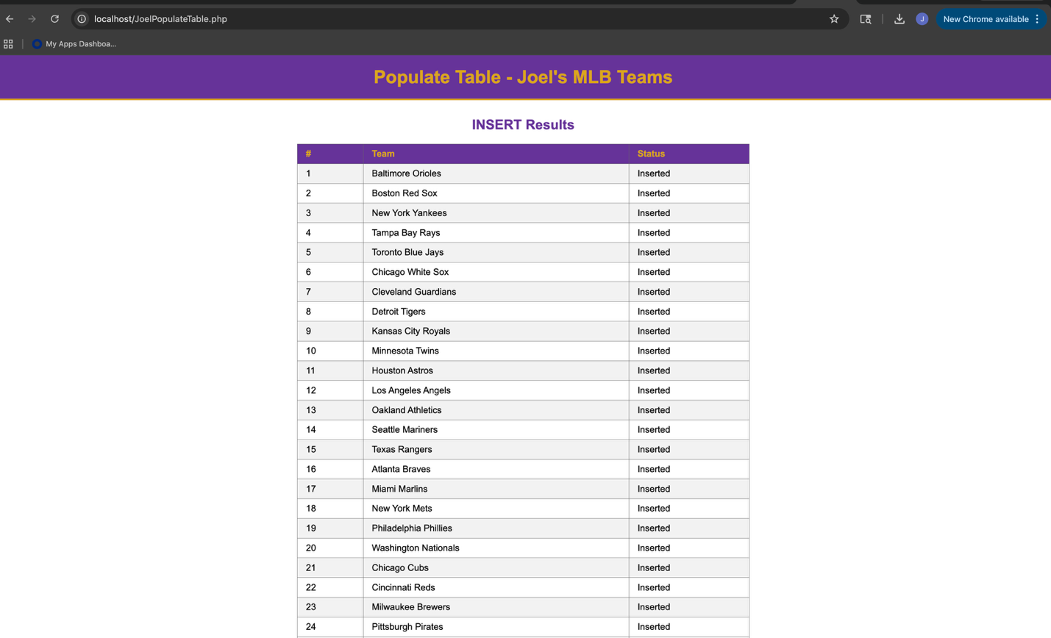
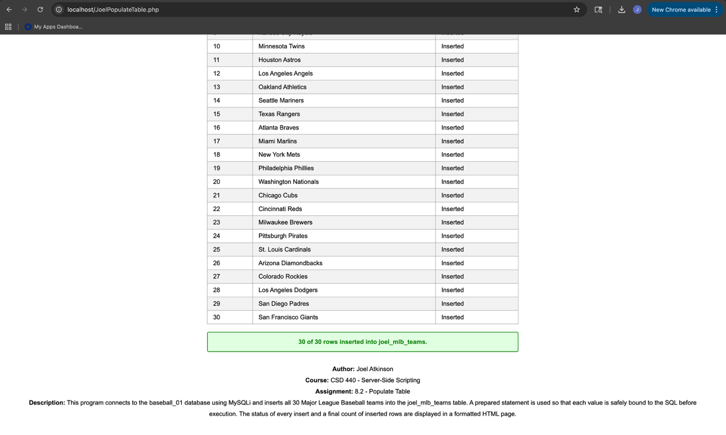
Screenshot of the table populated in the database on my php XAMPP dashboard:
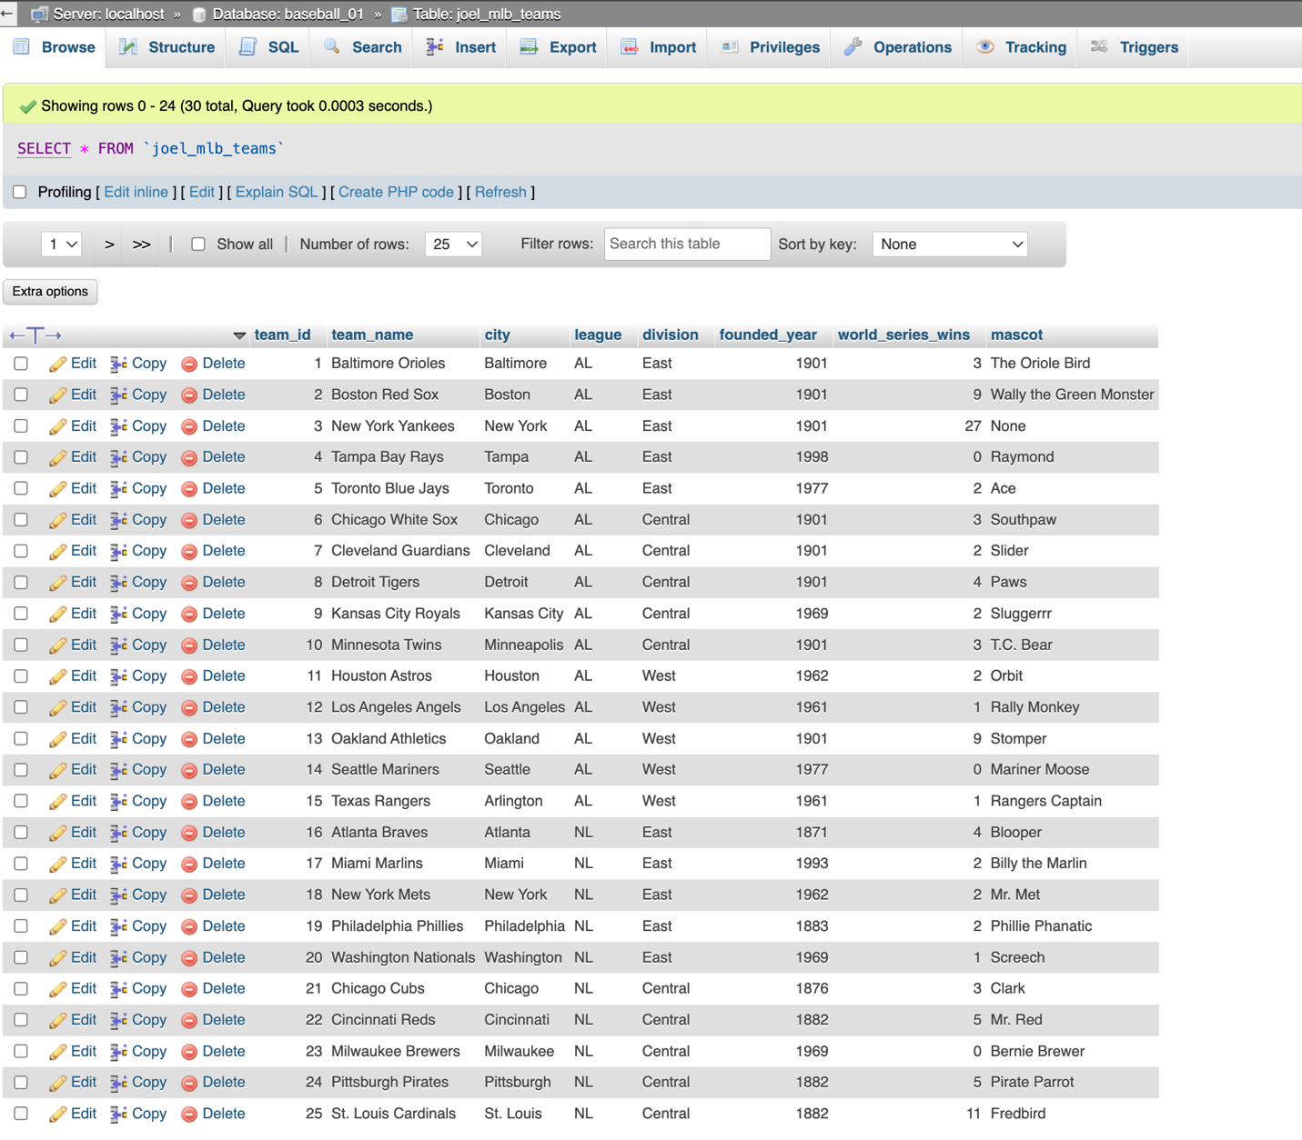

JoelQueryTable.php code:
<!-- Joel Atkinson, April 29, 2026. CSD440 Server-Side Scripting Assignment 8.2
The purpose of this program is to connect to the baseball_01 MySQL database using
MySQLi and run a SELECT query against the joel_mlb_teams table. The result set
is displayed in a formatted HTML table so the contents of the table can be
verified. The rows are sorted by World Series wins from highest to lowest so the
most successful franchises appear first.
-->
<!DOCTYPE html>
<html lang="en">
<head>
<meta charset="UTF-8">
<meta name="viewport" content="width=device-width, initial-scale=1.0">
<title>Joel's Query Table</title>
<style>
body {
font-family: Arial, sans-serif;
margin: 0;
}
.banner {
background-color: #663399;
padding: 20px 40px;
}
h1 {
color: #DAA520;
margin: 0;
text-align: center;
}
h2 {
color: #663399;
text-align: center;
margin-top: 30px;
}
.divider {
border: none;
border-top: 3px solid #DAA520;
margin: 0;
}
.content {
margin: 30px auto;
max-width: 1000px;
padding: 0 40px;
}
.success-box {
background-color: #e0ffe0;
border: 2px solid #008800;
color: #008800;
padding: 15px 20px;
border-radius: 4px;
margin: 20px 0;
text-align: center;
font-weight: bold;
}
.error-box {
background-color: #ffe0e0;
border: 2px solid #cc0000;
color: #cc0000;
padding: 15px 20px;
border-radius: 4px;
margin: 20px 0;
}
table {
border-collapse: collapse;
width: 100%;
margin: 20px 0;
}
th, td {
border: 1px solid #666;
padding: 8px 12px;
text-align: left;
}
th {
background-color: #663399;
color: #DAA520;
}
tr:nth-child(even) {
background-color: #f2f2f2;
}
.info {
text-align: center;
color: black;
margin: 20px 40px 40px;
line-height: 1.8;
}
</style>
</head>
<body>
<div class="banner">
<h1>Query Table - Joel's MLB Teams</h1>
</div>
<hr class="divider">
<div class="content">
<h2>SELECT Results</h2>
<?php
// Database connection variables for the baseball_01 MySQL database
$servername = "localhost";
$username = "student1";
$password = "pass";
$database = "baseball_01";
// Open a new connection to the MySQL server using MySQLi
$conn = new mysqli($servername, $username, $password, $database);
// Check that the connection was opened successfully
if ($conn->connect_error) {
echo '<div class="error-box"><strong>Connection failed:</strong> '
. htmlspecialchars($conn->connect_error) . '</div>';
echo '</div></body></html>';
exit;
}
// SELECT query that returns all rows from joel_mlb_teams, ordered by the
// number of World Series wins from highest to lowest so the most successful
// franchises appear first.
$sql = "SELECT team_id, team_name, city, league, division,
founded_year, world_series_wins, mascot
FROM joel_mlb_teams
ORDER BY world_series_wins DESC, team_name ASC";
$result = $conn->query($sql);
// Check whether the query ran and returned any rows
if ($result === false) {
echo '<div class="error-box"><strong>Query failed:</strong> '
. htmlspecialchars($conn->error) . '</div>';
} elseif ($result->num_rows === 0) {
echo '<div class="error-box">No rows were returned from joel_mlb_teams. '
. 'Run JoelPopulateTable.php to load sample data first.</div>';
} else {
// Show how many rows were returned
echo '<div class="success-box">'
. $result->num_rows . ' rows returned from joel_mlb_teams.</div>';
// Build the result table with one column per field
echo '<table>';
echo '<tr>';
echo '<th>ID</th>';
echo '<th>Team</th>';
echo '<th>City</th>';
echo '<th>League</th>';
echo '<th>Division</th>';
echo '<th>Founded</th>';
echo '<th>WS Wins</th>';
echo '<th>Mascot</th>';
echo '</tr>';
// Loop through every row and display each value in its own cell
while ($row = $result->fetch_assoc()) {
echo '<tr>';
echo '<td>' . htmlspecialchars($row["team_id"]) . '</td>';
echo '<td>' . htmlspecialchars($row["team_name"]) . '</td>';
echo '<td>' . htmlspecialchars($row["city"]) . '</td>';
echo '<td>' . htmlspecialchars($row["league"]) . '</td>';
echo '<td>' . htmlspecialchars($row["division"]) . '</td>';
echo '<td>' . htmlspecialchars($row["founded_year"]) . '</td>';
echo '<td>' . htmlspecialchars($row["world_series_wins"]) . '</td>';
echo '<td>' . htmlspecialchars($row["mascot"]) . '</td>';
echo '</tr>';
}
echo '</table>';
// Free the result set once we are finished reading from it
$result->free();
}
// Close the database connection
$conn->close();
?>
</div>
<p class="info">
<strong>Author:</strong> Joel Atkinson<br>
<strong>Course:</strong> CSD 440 - Server-Side Scripting<br>
<strong>Assignment:</strong> 8.2 - Query Table<br>
<strong>Description:</strong> This program connects to the baseball_01 database using MySQLi
and runs a SELECT query against the joel_mlb_teams table. The result set is sorted by
World Series wins in descending order and rendered as a formatted HTML table so the
contents of the table can be verified field by field.
</p>
</body>
</html>

Screenshot of output when navigating to localhost/JoelQueryTable.php:
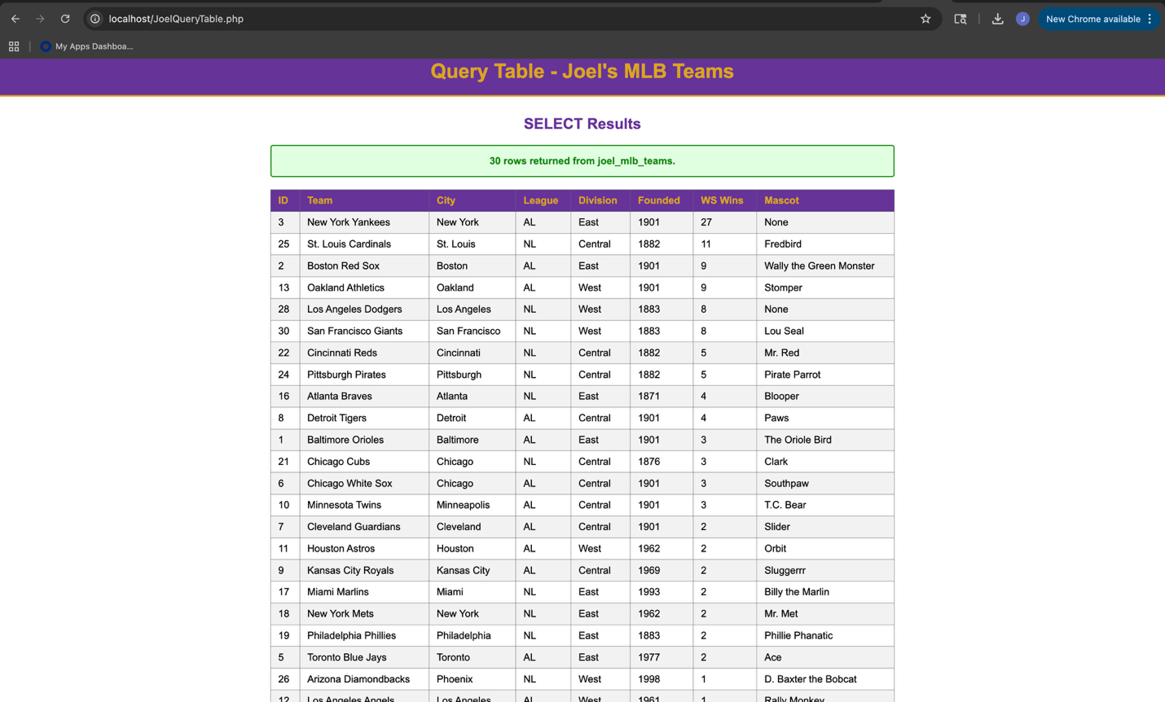

JoelDropTable.php code:
<!-- Joel Atkinson, April 30, 2026. CSD440 Server-Side Scripting Assignment 8.2
The purpose of this program is to connect to the baseball_01 MySQL database using
MySQLi and drop the joel_mlb_teams table. The DROP TABLE IF EXISTS form is used
so the program can be run safely whether or not the table currently exists. The
result of the operation is reported back to the user in a formatted page.
-->
<!DOCTYPE html>
<html lang="en">
<head>
<meta charset="UTF-8">
<meta name="viewport" content="width=device-width, initial-scale=1.0">
<title>Joel's Drop Table</title>
<style>
body {
font-family: Arial, sans-serif;
margin: 0;
}
.banner {
background-color: #663399;
padding: 20px 40px;
}
h1 {
color: #DAA520;
margin: 0;
text-align: center;
}
h2 {
color: #663399;
text-align: center;
margin-top: 30px;
}
.divider {
border: none;
border-top: 3px solid #DAA520;
margin: 0;
}
.content {
margin: 30px auto;
max-width: 700px;
padding: 0 40px;
}
.success-box {
background-color: #e0ffe0;
border: 2px solid #008800;
color: #008800;
padding: 15px 20px;
border-radius: 4px;
margin: 20px 0;
text-align: center;
font-weight: bold;
}
.error-box {
background-color: #ffe0e0;
border: 2px solid #cc0000;
color: #cc0000;
padding: 15px 20px;
border-radius: 4px;
margin: 20px 0;
}
.info {
text-align: center;
color: black;
margin: 20px 40px 40px;
line-height: 1.8;
}
</style>
</head>
<body>
<div class="banner">
<h1>Drop Table - Joel's MLB Teams</h1>
</div>
<hr class="divider">
<div class="content">
<h2>DROP TABLE Result</h2>
<?php
// Database connection variables for the baseball_01 MySQL database
$servername = "localhost";
$username = "student1";
$password = "pass";
$database = "baseball_01";
// Open a new connection to the MySQL server using MySQLi
$conn = new mysqli($servername, $username, $password, $database);
// Check that the connection was opened successfully
if ($conn->connect_error) {
echo '<div class="error-box"><strong>Connection failed:</strong> '
. htmlspecialchars($conn->connect_error) . '</div>';
echo '</div></body></html>';
exit;
}
// SQL statement that drops the joel_mlb_teams table.
// IF EXISTS is used so the script does not error if the table is already gone.
$sql = "DROP TABLE IF EXISTS joel_mlb_teams";
// Run the DROP TABLE statement and report the result
if ($conn->query($sql) === TRUE) {
echo '<div class="success-box">Table "joel_mlb_teams" dropped successfully '
. '(or did not exist).</div>';
} else {
echo '<div class="error-box"><strong>Error dropping table:</strong> '
. htmlspecialchars($conn->error) . '</div>';
}
// Close the database connection
$conn->close();
?>
</div>
<p class="info">
<strong>Author:</strong> Joel Atkinson<br>
<strong>Course:</strong> CSD 440 - Server-Side Scripting<br>
<strong>Assignment:</strong> 8.2 - Drop Table<br>
<strong>Description:</strong> This program connects to the baseball_01 database using MySQLi
and runs a DROP TABLE IF EXISTS statement that removes the joel_mlb_teams table from the
database. Using the IF EXISTS clause allows this script to be run safely regardless of
whether the table is currently present. The result of the operation is displayed in a
formatted HTML page.
</p>
</body>
</html>

Screenshot of output when navigating to localhost/JoelDropTable.php:
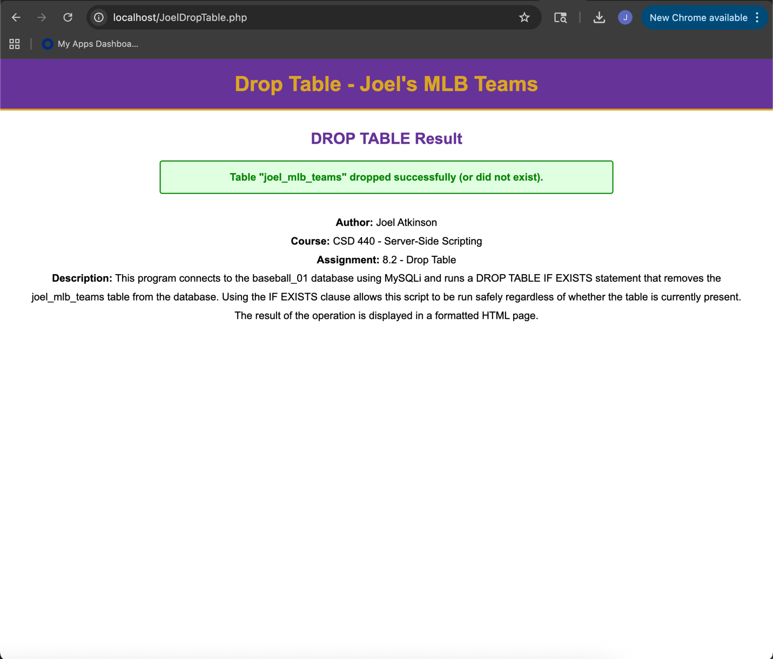
Screenshot of my php XAMPP dashboard showing that the table is no longer populated in the baseball_01 database:
